TIC TAC TOE Game

## A Project Work

*Submitted in the partial fulfillment for the award of the degree of*

# BACHELOR OF ENGINEERING

**in**

**Artificial Intelligence and Machine Learning**

## Submitted by:

**Hardik Sharma 20BCS6355**

**Under the Supervision of: Neeshu Ma’am**



**DEPARTMENT OF COMPUTER SCIENCE AND ENGINEERING APEX INSTITUE OF TECHNOLOGY**

**CHANDIGARH UNIVERSITY, GHARUAN, MOHALI - 140413, PUNJAB**

**JULY 2021**

# DECLARATION

I, **‘Hardik Sharma’**  student of **‘Bachelor of Engineering in Artifical Intelligence and Machine Learning ’**, **session: 2020-21** , Department of Computer Science and Engineering, Apex Institute of Technology, Chandigarh University, Punjab, hereby declare that the work presented in this Project Work entitled “**TIC TAC TOE Game”** is the outcome of our own bona fide work and is correct to the best of our knowledge and this work has been undertaken taking care of Engineering Ethics. It contains no material previously published or written by another person nor material which has been accepted for the award of any other degree or diploma of the university or other institute of higher learning, except where due acknowledgment has been made in the text.

## Hardik Sharma

## 20BCS6355

**Date: 25TH July 2021 Place: Home**

# Introduction

## This is a simple TIC TAC TOE game which is made in C++ programming language

* + **In this game, the questions are about C++ concepts and basic computer knowledge.**
  + **It is the C++ console application.**
  + **This game uses board to control players. In each turn players enter a number and choose a move before selecting the player symbol i.e. X or 0.**

1. **PROBLEM FORMULATION**

* Changes scope of learning: Since the questions can be based on any subject and that are random so it requires critical thinking and extensive research & Students get into the habit of innovative learning.
* A simple game like tic-tac-toe can be a mirror of how people move through obstacles and handle decisions in life. It also shows you that the pluses outweigh the minuses and that you learn how to develop strategies to help you pull through.
* Because of the simplicity of tic-tac-toe, it is often used as a pedagogical tool for teaching the concepts of good sportsmanship.
* If played optimally by both players, the game always ends in a draw, making tic-tac-toe a futile game.

# RESEARCH OBJECTIVES

1. In this project user,

* •   Can Keep track of scores.
* •   Can not win by unfair means
* •   Need to wait for 2nd player turn

# METHODOLOGY

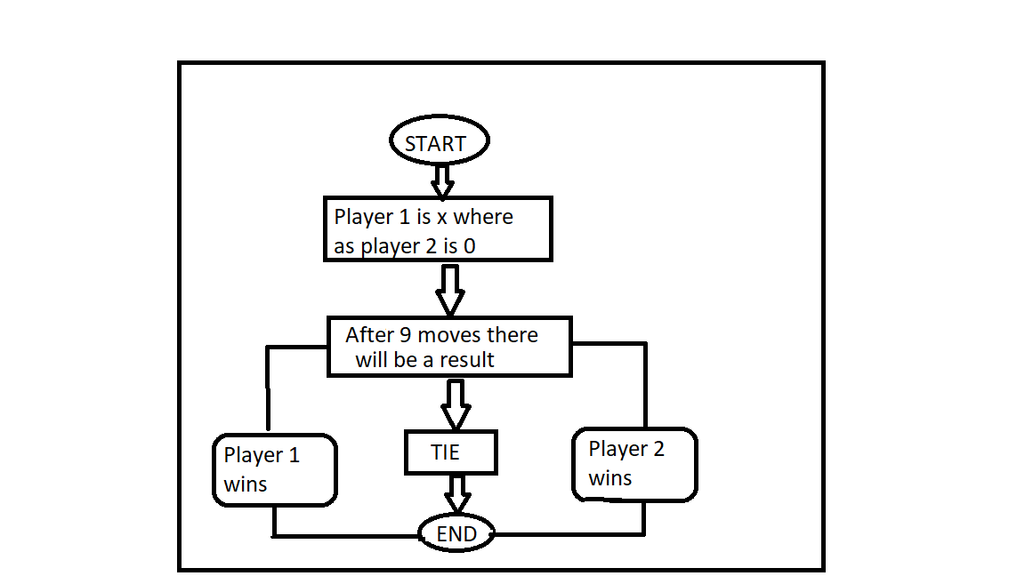

1. **RESULTS AND DISCUSSION**

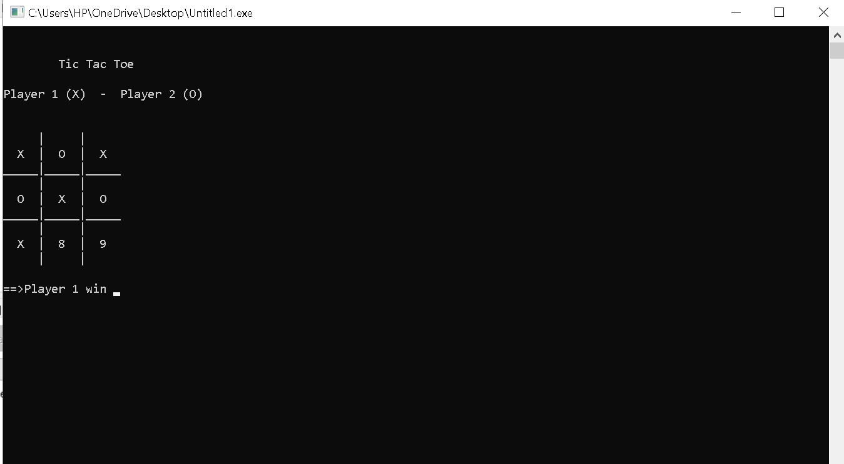

* **Tic-tac-toe is a game for two players, X and O, who take turns marking the spaces in a 3x3 grid. The player who succeeds in placing three of their marks in a horizontal, vertical, or diagonal row wins the game. Tic-tac-toe is a game which can be played by people of all ages, any time, anywhere. The game is usually used in enhancing the players thinking by teaching concepts of good sportsmanship.**

**Pitfalls: We couldn’t make a another move than ‘X’ and ‘0’ as it will give the invalid move. If the game gets equal it will draw.**

1. **REFERENCES**
2. <https://www.geeksforgeeks.org/quiz-game-in-c/>
3. <https://www.youtube.com/watch?v=7Vn5B6g_FLc>